ST. XAVIER’S COLLEGE

**(Affiliated to Tribhuvan University)**

**Maitighar, Kathmandu**



**Computer Graphics**

**Lab Assignment # 6**

**Mid-Point Ellipse Algorithm in C++ Builder**

**SUBMITTED BY:**

**Apil Neupane**

**013BSCCSIT008**

**SUBMITTED TO:**

|  |  |
| --- | --- |
| **Er. Anil K. Sah**  **Lecturer** |  |
| **Department of Computer Science** | |

Submission Date: 25thAugust 2015

**STATEMENT**

**Write a program to draw an ellipse using mid-point circle Algorithm in C++ Builder.**

**SOURCE CODE:**

//---------------------------------------------------------------------------

#include <vcl\vcl.h>

#pragma hdrstop

#include "Ellipse.h"

//---------------------------------------------------------------------------

#pragma resource "*.dfm"

TForm1 *Form1;

int rx, ry, x, y, xc, yc, p;

//---------------------------------------------------------------------------

__fastcall TForm1::TForm1(TComponent* Owner)

: TForm(Owner)

{

}

//---------------------------------------------------------------------------

void __fastcall TForm1::Edit1Change(TObject *Sender)

{

rx = StrToInt(Edit1->Text);

}

//---------------------------------------------------------------------------

void __fastcall TForm1::Edit2Change(TObject *Sender)

{

ry = StrToInt(Edit2->Text);

}

//---------------------------------------------------------------------------

void __fastcall TForm1::Edit3Change(TObject *Sender)

{

xc = StrToInt(Edit3->Text);

}

//---------------------------------------------------------------------------

void __fastcall TForm1::Edit4Change(TObject *Sender)

{

yc = StrToInt(Edit3->Text);

}

//---------------------------------------------------------------------------

void __fastcall TForm1::Button1Click(TObject *Sender)

{

x=0;

y=ry;

p=(ry*ry)-(rx*rx*ry)+((rx*rx)/4);

while ((2*x*ry*ry)<(2*y*rx*rx))

{

Image1->Canvas->Pixels[xc+x][yc-y]=RGB(128,220,245);

Image1->Canvas->Pixels[xc-x][yc+y]=RGB(98,180,250);

Image1->Canvas->Pixels[xc+x][yc+y]=RGB(105,249,85);

Image1->Canvas->Pixels[xc-x][yc-y]=RGB(225,175,75);

if(p<0)

{

x=x+1;

p=p+(2*ry*ry*x)+(ry*ry);

}

else

{

x=x+1;

y=y-1;

p=p+(2*ry*ry*x+ry*ry)-(2*rx*rx*y);

}

}

p=((float)x+0.5)*((float)x+0.5)*ry*ry+(y-1)*(y-1)*rx*rx-rx*rx*ry*ry;

while(y>=0)

{

Image1->Canvas->Pixels[xc+x][yc-y]=RGB(128,220,245);

Image1->Canvas->Pixels[xc-x][yc+y]=RGB(98,180,250);

Image1->Canvas->Pixels[xc+x][yc+y]=RGB(105,249,85);

Image1->Canvas->Pixels[xc-x][yc-y]=RGB(225,175,75);

if(p>0)

{

y=y-1;

p=p-(2*rx*rx*y)+(rx*rx);

}

else

{

y=y-1;

x=x+1;

p=p+(2*ry*ry*x)-(2*rx*rx*y)-(rx*rx);

}

}

}

//---------------------------------------------------------------------------

**OUTPUT:**

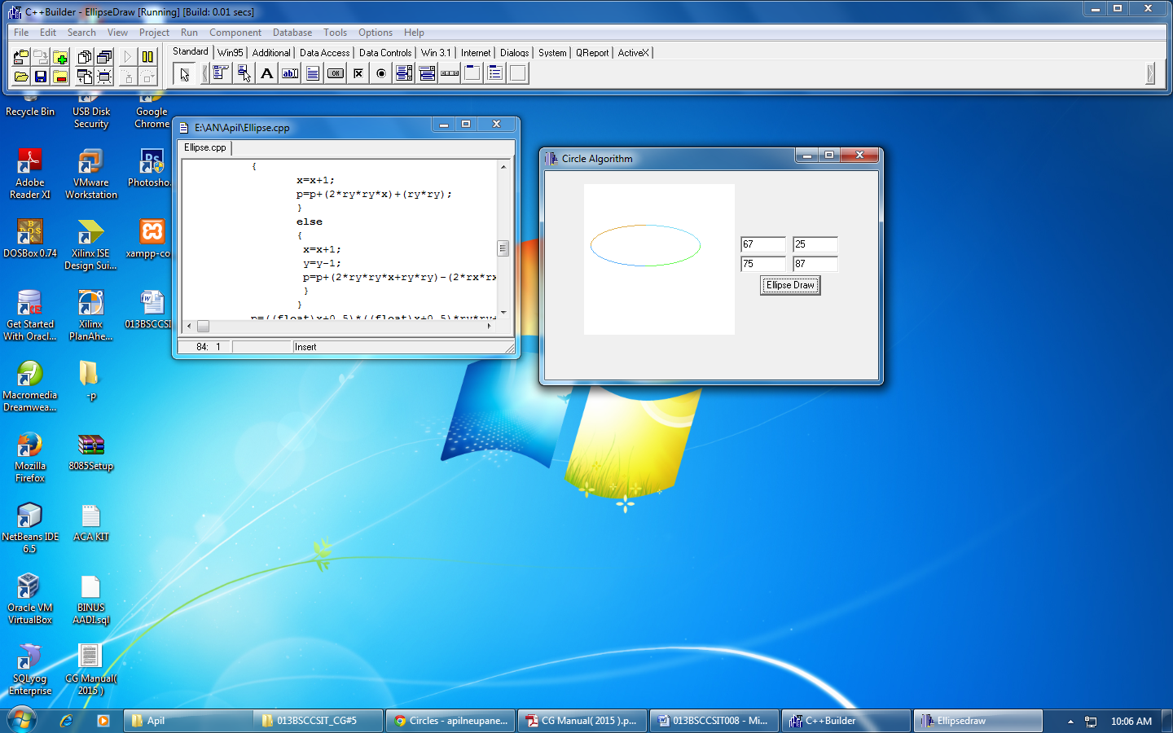

**CONCLUSION:**

Hence, a program to draw an ellipse using mid-point Algorithm was implemented in C++ Builder.